Project Report

The project Focuses on the following

* Obtain data from Quandl and the sp500 csv file and form a dataframe
* Using the data selected, write functions to find the optimal portfolio among given stocks.
* For the data and model chosen, estimate the impact of changing the time frame in model creating and utilization
* DEVELOP A STRATEGY FOR FORMING A PORTFOLIO THAT WILL SATISFY A CLIENT’S RISK TOLERANCE

The Project contains Three main Functions

* getPrice
* getminvarportf
* geteffret

getPrice – It is used to do data wrangling

getminvarportf – This function is used to get the minimum variance portfolio

geteffret – This function is used to get the minimum variance portfolio for a given expected return

**getprice:**

This is the function for data wrangling

This function accepts the following arguments

ListofSymbols – This is the list of Ticker symbols

Startdate – This is the start date for downloading the stock data

End date – This is the end date for downloading the stock data

In the function first the Date is validated

The sp500 csv file is loaded into R.

Then the data is obtained from Quandl for all the ticker stocks during the given time frame and the data is stored in a single dataframe called “stockdf”

Then this “stockdf” is returned by the function

Also error checking if done to see if the ticker symbol exists and to check if the API call is executed successfully

**getminvarportf:**

This function is used to obtain the minimum variance portfolio

This function accepts the following arguments

* Symbolvect – list of ticker symbols
* Startdate
* Enddate

First the “getPrice” Function is called within this function to get the “stockdf”

Then this “stockdf” dataframe is manipulated from long to wide format to obtain a dataframe which looks like the table below. lets say IBM,GM and MSFT ticker symbols were given, we would get a dataframe like this

IBM GM MSFT

return val return val return val

return val return val return val

return val return val return val

Then the covariance matrix is obtained using the following function

cov(dfwide, use="pairwise.complete.obs",method="pearson")

After this the function performs several operations to obtain the portfolio weights and variance of the portfolio

Then the minimum variance portfolio weights and variance of the portfolio are returned by this function

**Geteffret**

This function is used to get the minimum variance portfolio for a particular expected return

This function accepts the following arguments

* Symbolvect – list of ticker symbols
* Startdate
* Enddate
* Expectedreturn

First the “getPrice” Function is called within this function to get the “stockdf”

Then it performs similar operations such as getminvarportf function and it returns the following

* The minimum variance portfolio weights for given expected return
* Variance of the portfolio

Then several test cases are provided in the code

Ex:

#initialize test case 1

(mySymbols<-c("GM","MSFT","AAPL"))

start = "2015-05-03"

end = "2015-05-08"

Initialize the variables in a test case and then execute the following code

#After initializing a test case execute the following

#min variance portfolio - use these to get weights and variance for initialized cases

weights <- getminvarportf(mySymbols,start,end)[1]

#this gives variance of portfolio

portfoliovariance <- getminvarportf(mySymbols,start,end)[2]

print(weights)

print(portfoliovariance)

This will give minimum variance portfolio weights and the variance of the portfolio

If you need the minimum variance portfolio for a particular expected return, execute the following code in the R file after initializing the variables in a test case

#effecient portfolio for expected return

expectedret = 0.04 ( This is the expected return, it can be changed according to your wish)

#this gives minimum variance portfolio weights for given expected return

effweights <- geteffret(mySymbols,expectedret,start,end)[1]

#this gives variance of portfolio

effportfoliovar <- geteffret(mySymbols,expectedret,start,end)[2]

print(effweights)

print(effportfoliovar)

This will print the minimum variance portfolio weights for a given expected return and the variance of that portfolio.

**Parametric stability analysis:**

For the data and model chosen, estimate the impact of changing the time frame in model creating and utilization

In this analysis a graph is drawn between change in variance of optimal portfolio and the different Time frames , I obtained similar graphs for several types of test cases

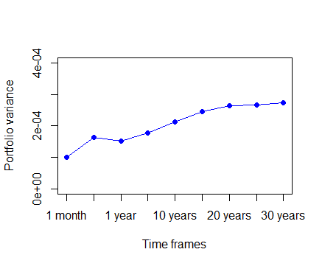

From the above graph you can see that the plot is flat for data which is taken for atleast twenty or more years .

For smaller data the plot varies a lot .

Hence after the analysis I deduce that in order to get a reliable portfolio weight the data for the past twenty years has to be taken.

The above graph was drawn from the below dataframe called analysisdf

timeframe portvarlist

[1,] "1 month" 0.0001003992

[2,] "six months" 0.0001631585

[3,] "1 year" 0.0001527627

[4,] "5 years" 0.0001765103

[5,] "10 years" 0.0002130328

[6,] "15 years" 0.0002466016

[7,] "20 years" 0.0002645121

[8,] "25 years" 0.0002660396

[9,] "30 years" 0.000274162

Portvarlist is the variance of the portfolio

**Extra credit work:**

STRATEGY FOR FORMING A PORTFOLIO THAT WILL SATISFY A CLIENT’S RISK TOLERANCE

In this the efficient frontier is found out. The result of this part is a dataframe which contains a set of portfolio weights for given stocks and their risks and expected return.

An example of the returned dataframe is this:

GM MSFT AAPL expected return risk

1 2.471711 -0.442927 -1.028784 0.0003662477 1.822756e-09

2 6.026948 -2.960502 -2.066446 0.0043296229 1.342014e-03

3 9.582185 -5.478078 -3.104107 0.0082929981 5.368049e-03

4 13.137422 -7.995653 -4.141769 0.0122563734 1.207811e-02

5 16.692659 -10.513229 -5.179431 0.0162197486 2.147219e-02

6 20.247896 -13.030804 -6.217092 0.0201831238 3.355030e-02

7 23.803133 -15.548380 -7.254754 0.0241464991 4.831243e-02

8 27.358370 -18.065955 -8.292415 0.0281098743 6.575858e-02

9 30.913608 -20.583531 -9.330077 0.0320732495 8.588876e-02

10 34.468845 -23.101106 -10.367738 0.0360366248 1.087030e-01

11 38.024082 -25.618682 -11.405400 0.0400000000 1.342012e-01

12 41.579319 -28.136257 -12.443062 0.0439633752 1.623834e-01

13 45.134556 -30.653832 -13.480723 0.0479267505 1.932497e-01

14 48.689793 -33.171408 -14.518385 0.0518901257 2.268000e-01

15 52.245030 -35.688983 -15.556046 0.0558535009 2.630343e-01

16 55.800267 -38.206559 -16.593708 0.0598168762 3.019527e-01

17 59.355504 -40.724134 -17.631370 0.0637802514 3.435550e-01

18 62.910741 -43.241710 -18.669031 0.0677436266 3.878414e-01

19 66.465978 -45.759285 -19.706693 0.0717070019 4.348118e-01

20 70.021215 -48.276861 -20.744354 0.0756703771 4.844663e-01

21 73.576452 -50.794436 -21.782016 0.0796337523 5.368047e-01

The name of the above dataframe is effrontierdf

The client can choose a portfolio corresponding to the amount of risk he is willing to take and the return he wants.

A graph plotted from the above data is given below

The graph contains expected return in y axis and the risk in one direction.

The minimum variance portfolio is also marked in the graph and its called as gmin

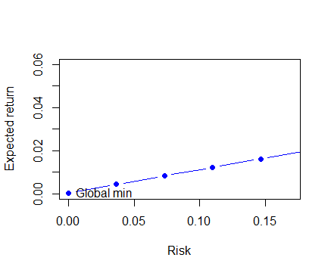

From the above graph you can see that expected return increases with more risk. The user can choose the portfolio he wants based on his risk tolerance an the return he wants

That’s it. Thanks.